DATE 17/3/2025

EXPERIMENT-21
IOT BASED SMART HOME APPLICATIONS

Aim: To implement IoT based smart home applications in Cisco Packet Tracer.
Software/Apparatus required: Packet Tracer/End devices, Hubs, connectors.
Procedure:
Steps:
- Create a network topology in Cisco Packet Tracer that includes IoT devices such as sensors, actuators, and gateways.
- Configure the IoT devices with appropriate IP addresses, subnet masks, and gateway addresses.
- Set up a communication protocol between the IoT devices using MQTT, CoAP, or any other protocol of your choice.
- Write a code to collect data from the sensors and send it to the gateway.
- Use the gateway to process the data and send commands to the actuators.
- Finally, use a web interface or mobile application to monitor and control the IoT devices. By following these steps an IoT-based smart application in Cisco Packet Tracer , can be created. This can be used for various applications such as home automation, smart cities, and industrial automation.

OUTPUT
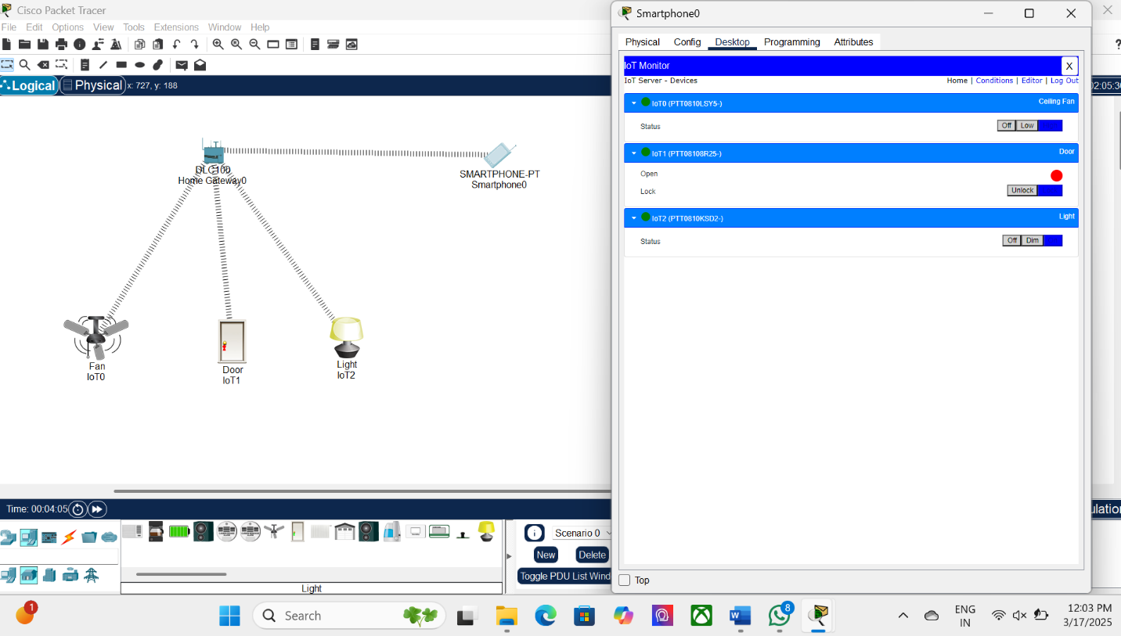

Result: Thus IoT based smart home applications in Cisco Packet Tracer is implemented successfully.

